Attitudes towards Physical Education
I enjoy PE and wish we had more lessons because we only have two lessons timetabled a week, but many others have different views. It is currently a compulsory subject throughout student’s time at school. Unfortunately, for many pupils they may not appreciate and enjoy the subject as much as others. Many don’t like the topic or simply favour other subjects. Also, they may not enjoy taking part in certain activities as many have very little interest in sport in general and this is often transferred into their opinion on the subject. This often makes pupils not want to partake in PE lessons and create a disinterest into the subject and the lessons. I have been around the school and asked many pupils taking part in the report whether they like or dislike PE. When asked do they like PE, 50% out of 20 pupils said that they like PE and the rest said they disliked it for differing reasons. I then asked the same people would they take PE as an option for their GCSE’s. Out of the twenty students, 6 said they would and the remaining 80% said they would rather take more academic subjects.
I asked Mrs. Davies-Boyle (English and Media Studies teacher) what her thoughts were on PE and she told me about how she took PE as a GCSE to prove to everyone who said she was bad at it that she could do it. She achieved an A Grade in the subject. Some of us grabbed the time to have a kick-about on the bank. Here are some photos:
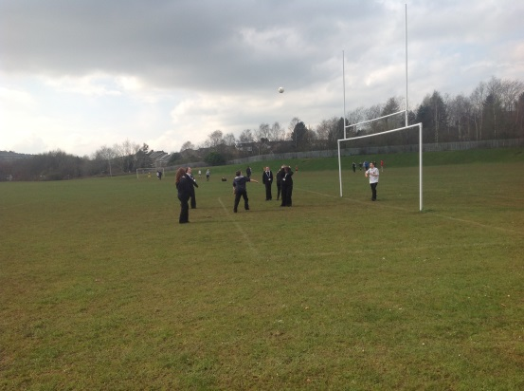
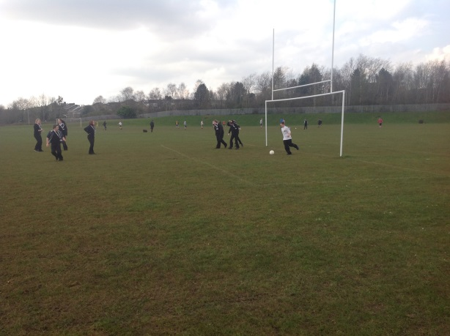

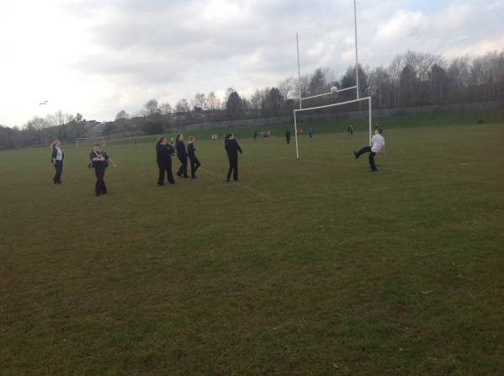
By Nathan

